**HiLCoE**

**Computer Science and Technology**

Rent Registeral system

Group Member

1.Amanuel Bitsuamlak

2.Amanuel Getachew

3.Amanuel Kefelegne

4. Dagim Sirabizu

To: Jafar Muzeyin

Date: Wednesday, December 21, 2021

**Functional Requirement**

* An app that would help Register Identity of the Renter into our Database on the Web app
* The Data Contains Their Basic information and their office number Floor and the rental payment and the Contract

**Non-Functional requirements**

* The main User of the System will be the Building or Real state Managers
* The System will give a Notification of the due date of the contract and the Payment

In addition to that the main goal of the System is to achieve simplicity in managing the Building Janitors, Security Professional in handling their data and contracts

**Major Topics**

* Register Rental Building
* Syncing to our Database

**Register Rental Building**

* As a user, I want to register rental building so that I can easily manage.
* As a user, I want add the contract so that I can control my money and payment.

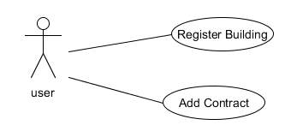

**Syncing to our Database**

* As a user, I want to sync to the database so that I can keep my data safely

